**Functions in C++**

1. Find factorial using function

#include<iostream>

using namespace std;

int factorial(int n){

int fact=1,i;

for(i=1;i<=n;i++){

fact*=i;

}

return fact;

}

int main(){

int n;

cout<<"enter a number:";

cin>>n;

int res=factorial(n);

cout<<res;

return 0;

}

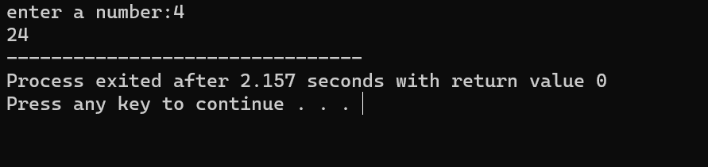

1. Find prime number using function

#include<iostream>

using namespace std;

bool isprime(int n){

for(int i=2;i<=n/2;i++){

if(n%i==0){

return false;

}

}

return true;

}

int main(){

int n;

cout<<"enter a number:";

cin>>n;

if(isprime(n)){

cout<<"prime";

}else{

cout<<"not prime";

}

return 0;

}

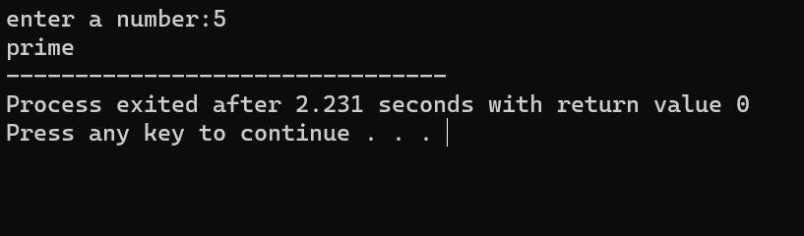

1. Find the reverse of a string using function

#include<iostream>

#include<string>

using namespace std;

string reversestring(string s){

int l=s.length();

for(int i=0;i<=l/2;i++){

swap(s[i],s[l-i-1]);

}

return s;

}

int main(){

string s;

cout<<"enter a string:";

cin>>s;

cout<<reversestring(s);

return 0;

}

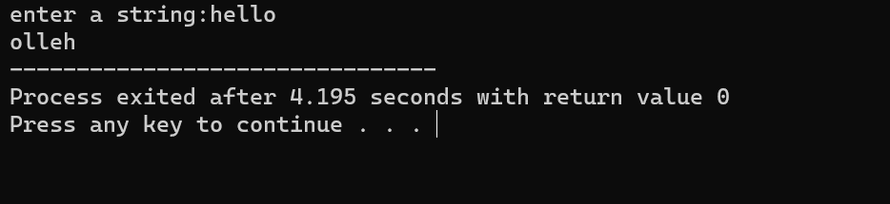

1. Find minimum and maximum element in an array using function

#include<iostream>

using namespace std;

int findmin(int arr[],int n){

int min=arr[0];

for(int i=1;i<n;i++){

if(arr[i] < min){

min=arr[i];

}

}

return min;

}

int findmax(int arr[],int n){

int max=arr[0];

for(int i=1;i<n;i++){

if(arr[i] > max){

max=arr[i];

}

}

return max;

}

int main(){

int arr[10],n;

cout<<"enter a number:";

cin>>n;

for(int i=0;i<n;i++){

cin>>arr[i];

}

int r1=findmin(arr,n);

int r2=findmax(arr,n);

cout<<"minimum="<<r1<<endl;

cout<<"maximum="<<r2<<endl;

}

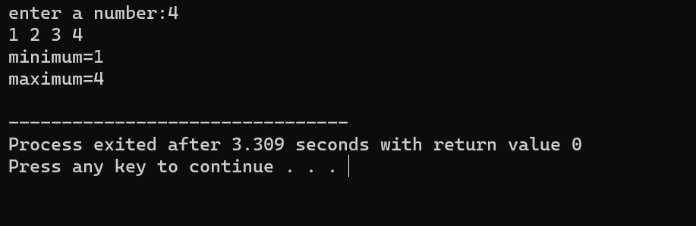

1. Find GCD of two number using function

#include<iostream>

using namespace std;

int findgcd(int a,int b){

if(b==0){

return a;

}else{

return findgcd(b,a%b);

}

}

int main(){

int a,b;

cout<<"enter 2 numbers:";

cin>>a>>b;

int r=findgcd(a,b);

cout<<"gcd ="<<r;

return 0;

}

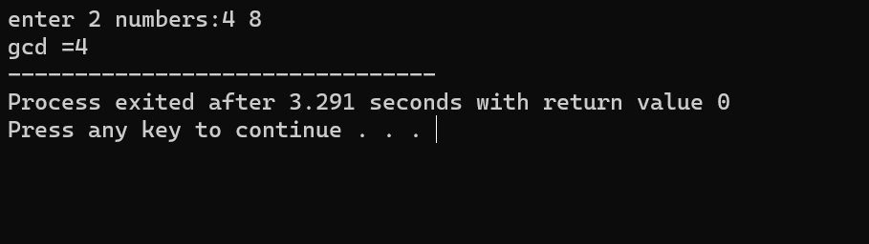

1. Function to count the no of elements in a string

#include <iostream>

#include <string>

using namespace std;

int countElements(string str) {

return str.length();

}

int main() {

string s;

cout << "Enter a string: ";

getline(cin, s);

cout << "Number of elements in the string: " << countElements(s) << endl;

return 0;

}

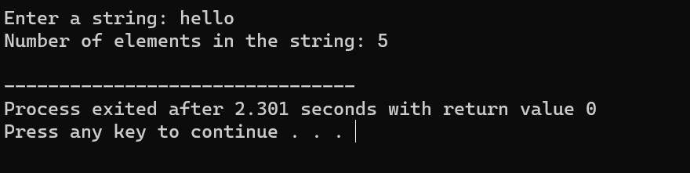

1. Convert Celsius and Fahrenheit using function

#include <iostream>

using namespace std;

double celsiusToFahrenheit(double celsius) {

return (celsius * 9 / 5) + 32;

}

double fahrenheitToCelsius(double fahrenheit) {

return (fahrenheit - 32) * 5 / 9;

}

int main() {

double temp;

char choice;

cout << "Enter temperature: ";

cin >> temp;

cout << "Convert to (C)elsius or (F)ahrenheit? ";

cin >> choice;

if (choice == 'F' || choice == 'f') {

cout << "Temperature in Fahrenheit: " << celsiusToFahrenheit(temp) << "°F" << endl;

} else if (choice == 'C' || choice == 'c') {

cout << "Temperature in Celsius: " << fahrenheitToCelsius(temp) << "°C" << endl;

} else {

cout << "Invalid choice!" << endl;

}

return 0;

}

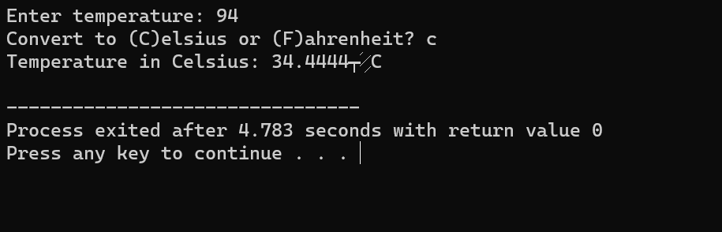

1. Find the area of a circle using function

#include <iostream>

using namespace std;

const double PI = 3.141592653589793;

double areaOfCircle(double radius) {

return PI * radius * radius;

}

int main() {

double radius;

cout << "Enter the radius of the circle: ";

cin >> radius;

cout << "Area of the circle: " << areaOfCircle(radius) << " square units" << endl;

return 0;

}

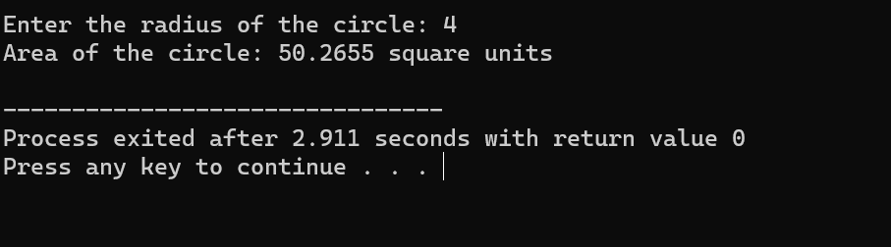

1. Check whether the string is palindrome or not

#include <iostream>

#include <string>

using namespace std;

bool isPalindrome(string str) {

int n = str.length();

for (int i = 0; i < n / 2; i++) {

if (str[i] != str[n - i - 1]) {

return false;

}

}

return true;

}

int main() {

string s;

cout << "Enter a string: ";

cin>>s;

if (isPalindrome(s)) {

cout << s << " is a palindrome." << endl;

} else {

cout << s << " is not a palindrome." << endl;

}

return 0;

}

